**Organisation des ateliers par périodes**



**2025/2026**

A vous de remplir la colonne ATELIERS selon votre organisation et votre dénomination

(ex : Atelier maîtresse/Atelier ATSEM/ Atelier autonome 1/Atelier autonome 2/ Coin jeux/ etc)

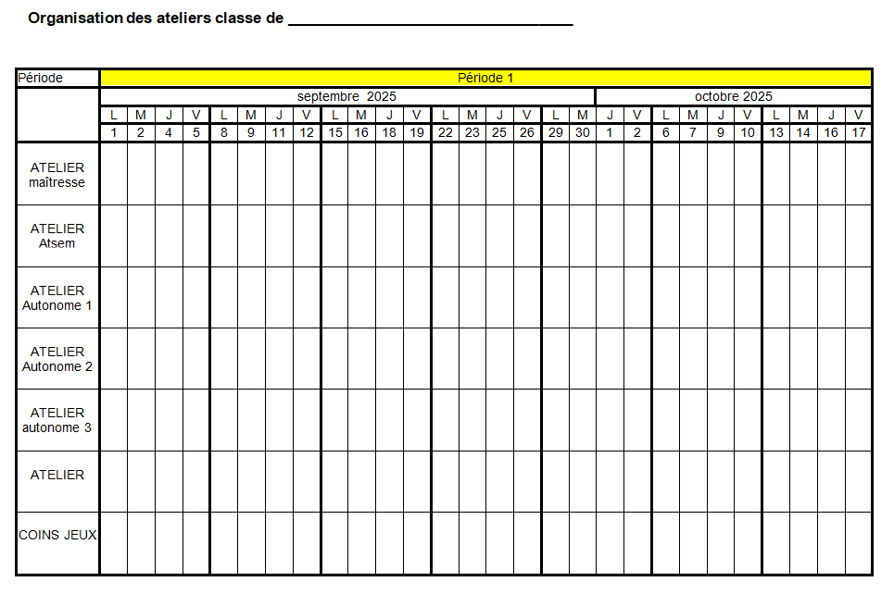

Selon votre zone :

-compléter la ligne des périodes pour les

périodes 3, 4 et 5 (début, fin, couleur)

-griser les périodes qui correspondent

à vos vacances scolaires

**Organisation des ateliers classe de __________________________________**

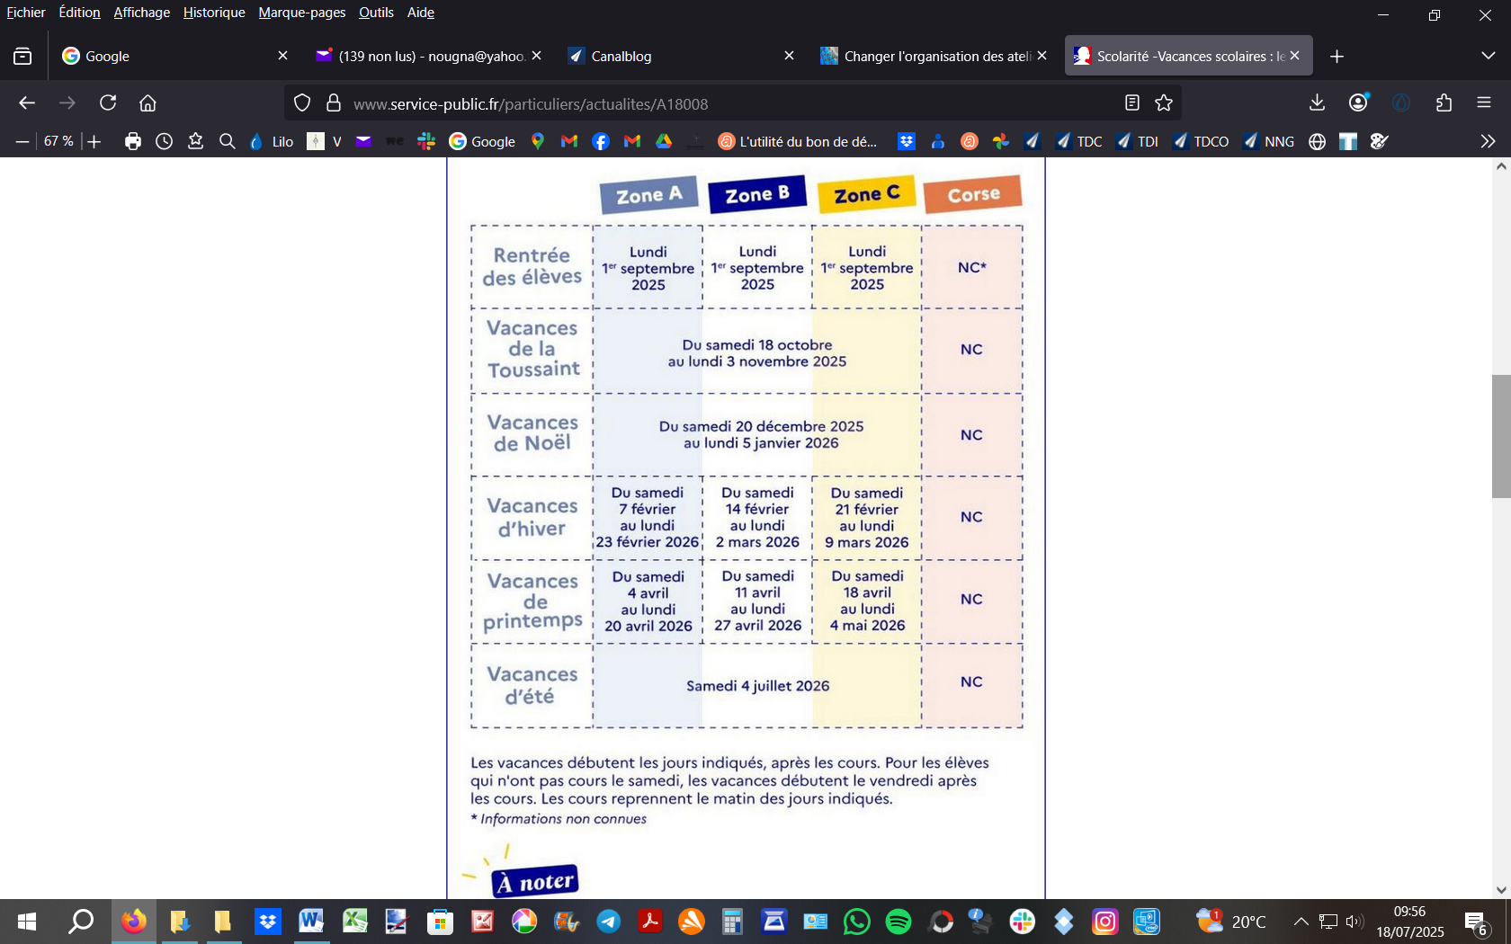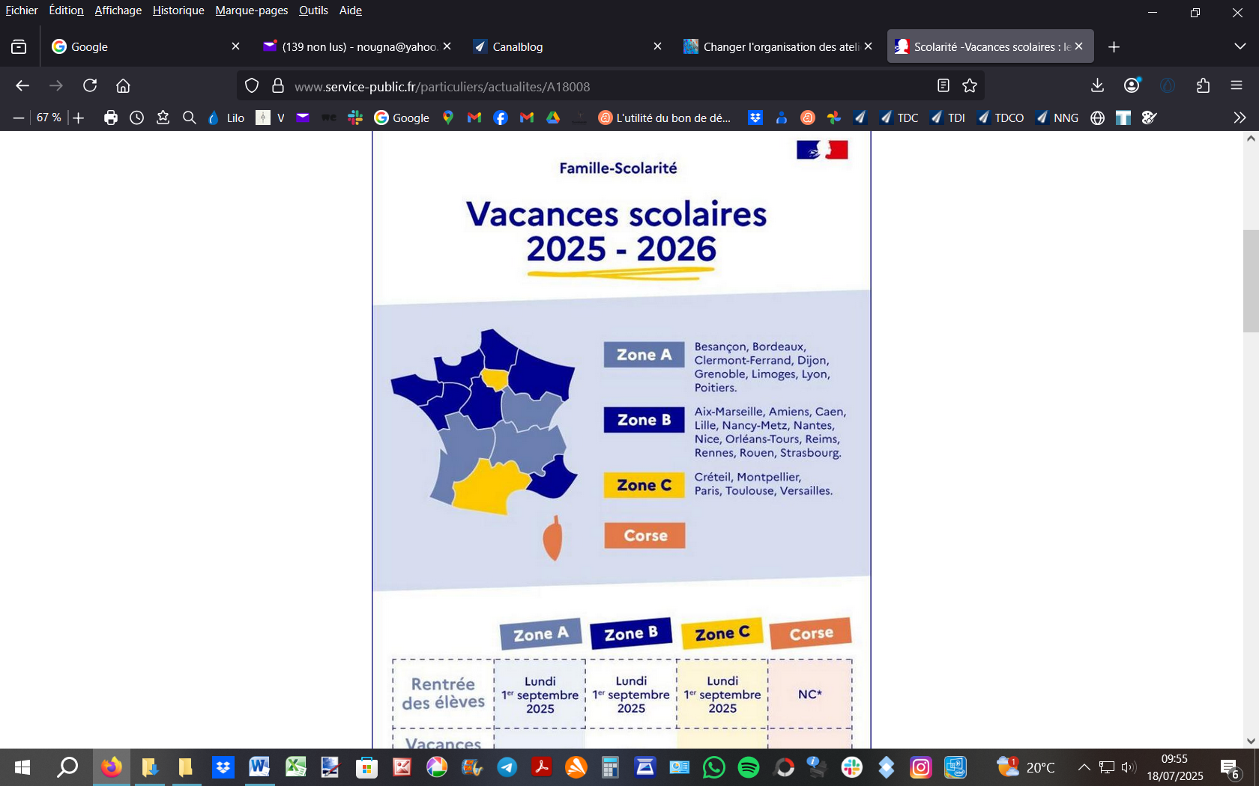

|  |  |  |  |  |  |  |  |  |  |  |  |  |  |  |  |  |  |  |  |  |  |  |  |  |  |  |  |  |  |
| --- | --- | --- | --- | --- | --- | --- | --- | --- | --- | --- | --- | --- | --- | --- | --- | --- | --- | --- | --- | --- | --- | --- | --- | --- | --- | --- | --- | --- | --- |
| Période | Période 1 | | | | | | | | | | | | | | | | | | | | | | | | | | | | |
| **ATELIERS** | septembre 2025 | | | | | | | | | | | | | | | | | | octobre 2025 | | | | | | | | | | |
| L | M | J | V | L | M | J | V | L | M | J | V | L | M | J | V | L | M | | J | V | L | M | J | V | L | M | J | V |
| 1 | 2 | 4 | 5 | 8 | 9 | 11 | 12 | 15 | 16 | 18 | 19 | 22 | 23 | 25 | 26 | 29 | 30 | | 1 | 2 | 6 | 7 | 9 | 10 | 13 | 14 | 16 | 17 |
|  |  |  |  |  |  |  |  |  |  |  |  |  |  |  |  |  |  |  | |  |  |  |  |  |  |  |  |  |  |
|  |  |  |  |  |  |  |  |  |  |  |  |  |  |  |  |  |  |  | |  |  |  |  |  |  |  |  |  |  |
|  |  |  |  |  |  |  |  |  |  |  |  |  |  |  |  |  |  |  | |  |  |  |  |  |  |  |  |  |  |
|  |  |  |  |  |  |  |  |  |  |  |  |  |  |  |  |  |  |  | |  |  |  |  |  |  |  |  |  |  |
|  |  |  |  |  |  |  |  |  |  |  |  |  |  |  |  |  |  |  | |  |  |  |  |  |  |  |  |  |  |
|  |  |  |  |  |  |  |  |  |  |  |  |  |  |  |  |  |  |  | |  |  |  |  |  |  |  |  |  |  |

**Organisation des ateliers classe de __________________________________**

|  |  |  |  |  |  |  |  |  |  |  |  |  |  |  |  |  |  |  |  |  |  |  |  |  |  |  |  |  |  |
| --- | --- | --- | --- | --- | --- | --- | --- | --- | --- | --- | --- | --- | --- | --- | --- | --- | --- | --- | --- | --- | --- | --- | --- | --- | --- | --- | --- | --- | --- |
| Période | Période 2 | | | | | | | | | | | | | | | | | | | | | | | | | | | | |
| **ATELIERS** | Novembre 2025 | | | | | | | | | | | | | | | | Décembre 2025 | | | | | | | | | | | | |
| L | M | J | V | L | M | J | V | L | M | J | V | L | M | J | V | | L | M | J | V | L | M | J | V | L | M | J | V |
| 3 | 4 | 6 | 7 | 10 | 11 | 13 | 14 | 17 | 18 | 20 | 21 | 24 | 25 | 27 | 28 | | 1 | 2 | 4 | 5 | 8 | 9 | 11 | 12 | 15 | 16 | 18 | 19 |
|  |  |  |  |  |  |  |  |  |  |  |  |  |  |  |  |  | |  |  |  |  |  |  |  |  |  |  |  |  |
|  |  |  |  |  |  |  |  |  |  |  |  |  |  |  |  |  | |  |  |  |  |  |  |  |  |  |  |  |  |
|  |  |  |  |  |  |  |  |  |  |  |  |  |  |  |  |  | |  |  |  |  |  |  |  |  |  |  |  |  |
|  |  |  |  |  |  |  |  |  |  |  |  |  |  |  |  |  | |  |  |  |  |  |  |  |  |  |  |  |  |
|  |  |  |  |  |  |  |  |  |  |  |  |  |  |  |  |  | |  |  |  |  |  |  |  |  |  |  |  |  |
|  |  |  |  |  |  |  |  |  |  |  |  |  |  |  |  |  | |  |  |  |  |  |  |  |  |  |  |  |  |

**Organisation des ateliers classe de __________________________________**

|  |  |  |  |  |  |  |  |  |  |  |  |  |  |  |  |  |  |  |  |  |  |  |  |  |  |  |  |  |  |
| --- | --- | --- | --- | --- | --- | --- | --- | --- | --- | --- | --- | --- | --- | --- | --- | --- | --- | --- | --- | --- | --- | --- | --- | --- | --- | --- | --- | --- | --- |
| Période |  | | | | | | | | | | | | | | | | | | | | | | | | | | | | |
| **ATELIERS** | Janvier 2026 | | | | | | | | | | | | | | | | | Février 2026 | | | | | | | | | | | |
| L | M | J | V | L | M | J | V | L | M | J | V | L | M | J | V | L | | M | J | V | L | M | J | V | L | M | J | V |
| 5 | 6 | 8 | 9 | 12 | 13 | 15 | 16 | 19 | 20 | 22 | 23 | 26 | 27 | 29 | 30 | 2 | | 3 | 5 | 6 | 9 | 10 | 12 | 13 | 16 | 17 | 19 | 20 |
|  |  |  |  |  |  |  |  |  |  |  |  |  |  |  |  |  |  | |  |  |  |  |  |  |  |  |  |  |  |
|  |  |  |  |  |  |  |  |  |  |  |  |  |  |  |  |  |  | |  |  |  |  |  |  |  |  |  |  |  |
|  |  |  |  |  |  |  |  |  |  |  |  |  |  |  |  |  |  | |  |  |  |  |  |  |  |  |  |  |  |
|  |  |  |  |  |  |  |  |  |  |  |  |  |  |  |  |  |  | |  |  |  |  |  |  |  |  |  |  |  |
|  |  |  |  |  |  |  |  |  |  |  |  |  |  |  |  |  |  | |  |  |  |  |  |  |  |  |  |  |  |
|  |  |  |  |  |  |  |  |  |  |  |  |  |  |  |  |  |  | |  |  |  |  |  |  |  |  |  |  |  |

**Organisation des ateliers classe de __________________________________**

|  |  |  |  |  |  |  |  |  |  |  |  |  |  |  |  |  |  |  |  |  |  |  |  |  |  |  |  |  |  |  |
| --- | --- | --- | --- | --- | --- | --- | --- | --- | --- | --- | --- | --- | --- | --- | --- | --- | --- | --- | --- | --- | --- | --- | --- | --- | --- | --- | --- | --- | --- | --- |
| Période |  | | | | | | | | | | | | | | | | | | | | | | | | | | | | | |
| **ATELIERS** | Février 2026 | | | | | Mars 2026 | | | | | | | | | | | | | | | | | | | Avril 2026 | | | | | |
| L | M | J | V | L | | M | J | V | L | M | J | V | L | M | J | V | L | M | J | V | L | M | J | | V | L | M | J | V |
| 23 | 24 | 26 | 27 | 2 | | 3 | 5 | 6 | 9 | 10 | 12 | 13 | 16 | 17 | 19 | 20 | 23 | 24 | 26 | 27 | 30 | 31 | 2 | | 3 | 6 | 7 | 9 | 10 |
|  |  |  |  |  |  | |  |  |  |  |  |  |  |  |  |  |  |  |  |  |  |  |  |  | |  |  |  |  |  |
|  |  |  |  |  |  | |  |  |  |  |  |  |  |  |  |  |  |  |  |  |  |  |  |  | |  |  |  |  |  |
|  |  |  |  |  |  | |  |  |  |  |  |  |  |  |  |  |  |  |  |  |  |  |  |  | |  |  |  |  |  |
|  |  |  |  |  |  | |  |  |  |  |  |  |  |  |  |  |  |  |  |  |  |  |  |  | |  |  |  |  |  |
|  |  |  |  |  |  | |  |  |  |  |  |  |  |  |  |  |  |  |  |  |  |  |  |  | |  |  |  |  |  |
|  |  |  |  |  |  | |  |  |  |  |  |  |  |  |  |  |  |  |  |  |  |  |  |  | |  |  |  |  |  |

**Organisation des ateliers classe de __________________________________**

|  |  |  |  |  |  |  |  |  |  |  |  |  |  |  |  |  |  |  |  |  |  |  |  |  |  |  |  |  |  |
| --- | --- | --- | --- | --- | --- | --- | --- | --- | --- | --- | --- | --- | --- | --- | --- | --- | --- | --- | --- | --- | --- | --- | --- | --- | --- | --- | --- | --- | --- |
| Période |  | | | | | | | | | | | | | | | | | | | | | | | | | | | | |
| **ATELIERS** | Avril 2026 | | | | | | | | | | | Mai 2026 | | | | | | | | | | | | | | | | | |
| L | M | J | V | L | M | J | V | L | M | J | | V | L | M | J | V | L | M | J | V | L | M | J | V | L | M | J | V |
| 13 | 14 | 16 | 17 | 20 | 21 | 23 | 24 | 27 | 28 | 30 | | 1 | 4 | 5 | 7 | 8 | 11 | 12 | 14 | 15 | 18 | 19 | 21 | 22 | 25 | 25 | 28 | 29 |
|  |  |  |  |  |  |  |  |  |  |  |  | |  |  |  |  |  |  |  |  |  |  |  |  |  |  |  |  |  |
|  |  |  |  |  |  |  |  |  |  |  |  | |  |  |  |  |  |  |  |  |  |  |  |  |  |  |  |  |  |
|  |  |  |  |  |  |  |  |  |  |  |  | |  |  |  |  |  |  |  |  |  |  |  |  |  |  |  |  |  |
|  |  |  |  |  |  |  |  |  |  |  |  | |  |  |  |  |  |  |  |  |  |  |  |  |  |  |  |  |  |
|  |  |  |  |  |  |  |  |  |  |  |  | |  |  |  |  |  |  |  |  |  |  |  |  |  |  |  |  |  |
|  |  |  |  |  |  |  |  |  |  |  |  | |  |  |  |  |  |  |  |  |  |  |  |  |  |  |  |  |  |

**Organisation des ateliers classe de __________________________________**

|  |  |  |  |  |  |  |  |  |  |  |  |  |  |  |  |  |  |  |  |  |  |  |
| --- | --- | --- | --- | --- | --- | --- | --- | --- | --- | --- | --- | --- | --- | --- | --- | --- | --- | --- | --- | --- | --- | --- |
| Période |  | | | | | | | | | | | | | | | | | | |  | | |
| **ATELIERS** | Juin 2026 | | | | | | | | | | | | | | | | | | Juillet 2026 | | | |
| L | M | J | V | L | M | J | V | L | M | J | V | L | M | J | V | L | M | J | | V | VACANCES |
| 1 | 2 | 4 | 5 | 8 | 9 | 11 | 12 | 15 | 16 | 18 | 19 | 22 | 23 | 25 | 26 | 29 | 30 | 2 | | 3 |
|  |  |  |  |  |  |  |  |  |  |  |  |  |  |  |  |  |  |  |  | |  |
|  |  |  |  |  |  |  |  |  |  |  |  |  |  |  |  |  |  |  |  | |  |
|  |  |  |  |  |  |  |  |  |  |  |  |  |  |  |  |  |  |  |  | |  |
|  |  |  |  |  |  |  |  |  |  |  |  |  |  |  |  |  |  |  |  | |  |
|  |  |  |  |  |  |  |  |  |  |  |  |  |  |  |  |  |  |  |  | |  |
|  |  |  |  |  |  |  |  |  |  |  |  |  |  |  |  |  |  |  |  | |  |